About Hacking Club
Hacking Club is a platform to learn cybersecurity, an incredible resource if you don’t know where to start. In addition to vulnerable machines, you have access to classes and challenges to practice your skills and access to an exclusive community to play and challenge yourself.

The best part about Hacking Club is that it is very hands-on. If you are new to hacking, give it a try.

Introduction
This write-up refers to the ONE WORLD machine.If you require support, please open a ticket in the support channel on the Discord server.

Enumeration
Enumerating the target machine’s ports, we see that ports 22 and 80 are open:
rustscan -a <machine-ip>
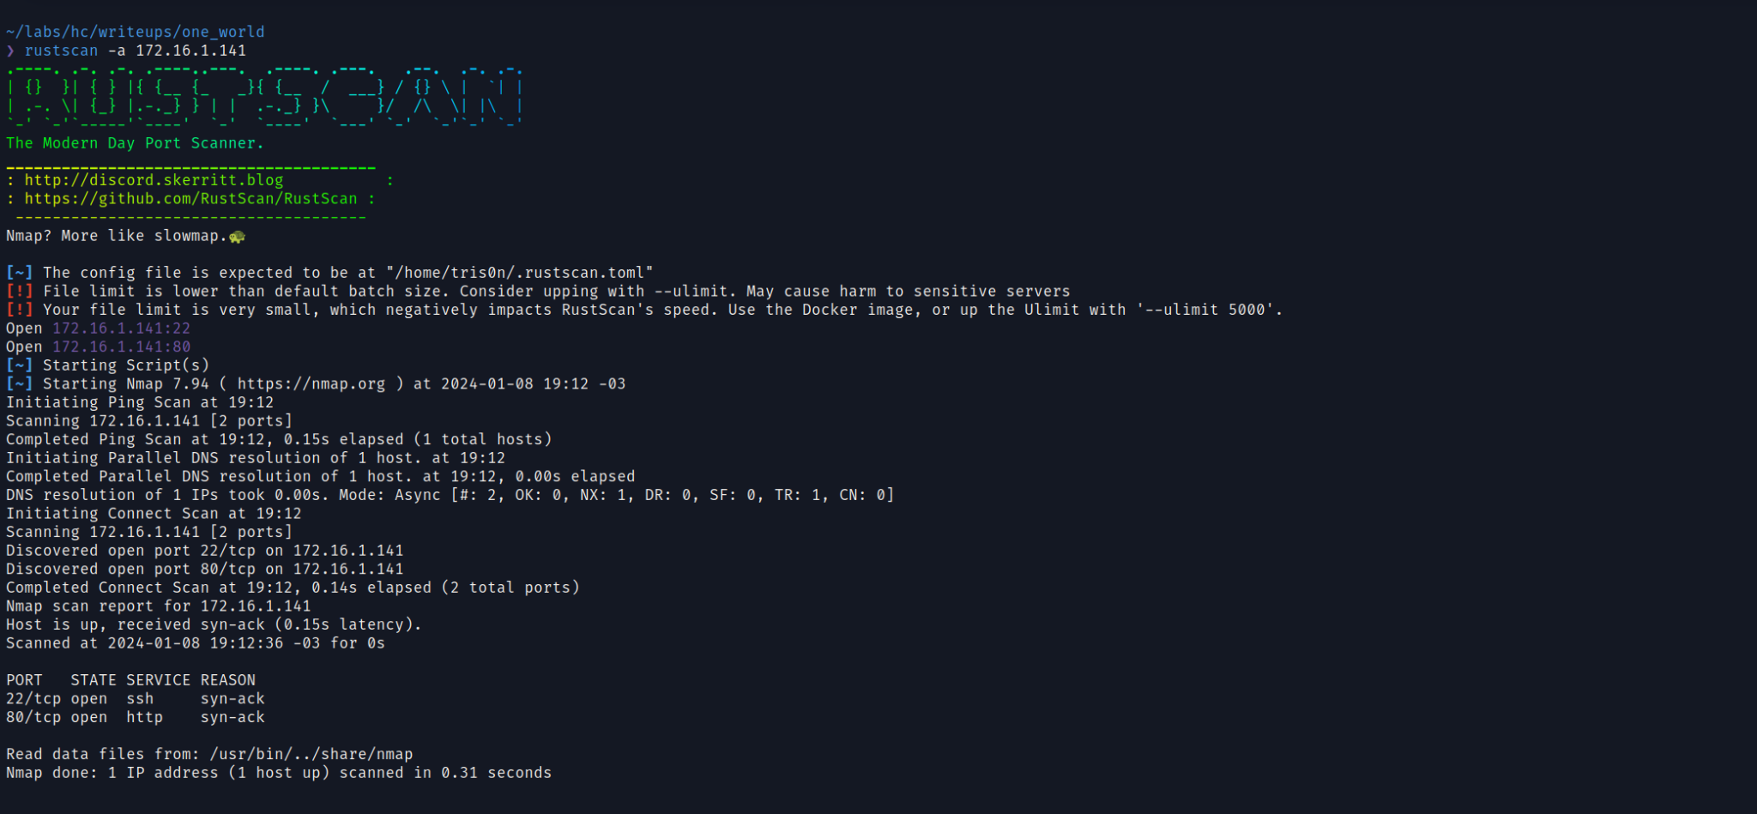

Analyzing the web server headers, we see that there is a redirection to “oneworld.hc”:
curl -I <machine-ip>

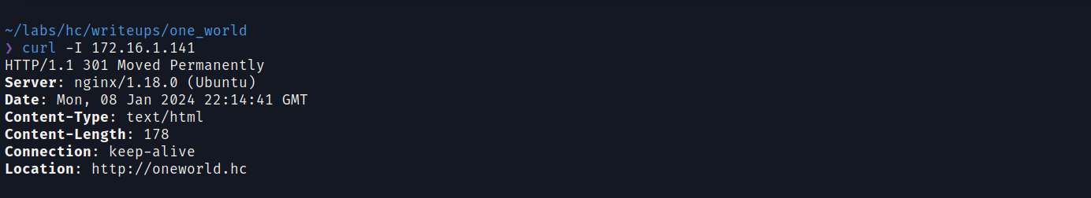
Adding the vhost to /etc/hosts:
sudo nano /etc/hosts
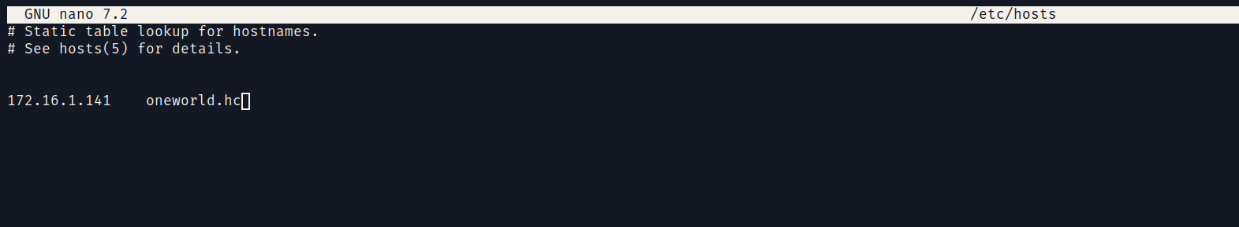
Accessing the vhost, we see the following page.

Reading the content of this page, we can see that the application likely uses EJS (Embedded JavaScript Templates) as its templating system.
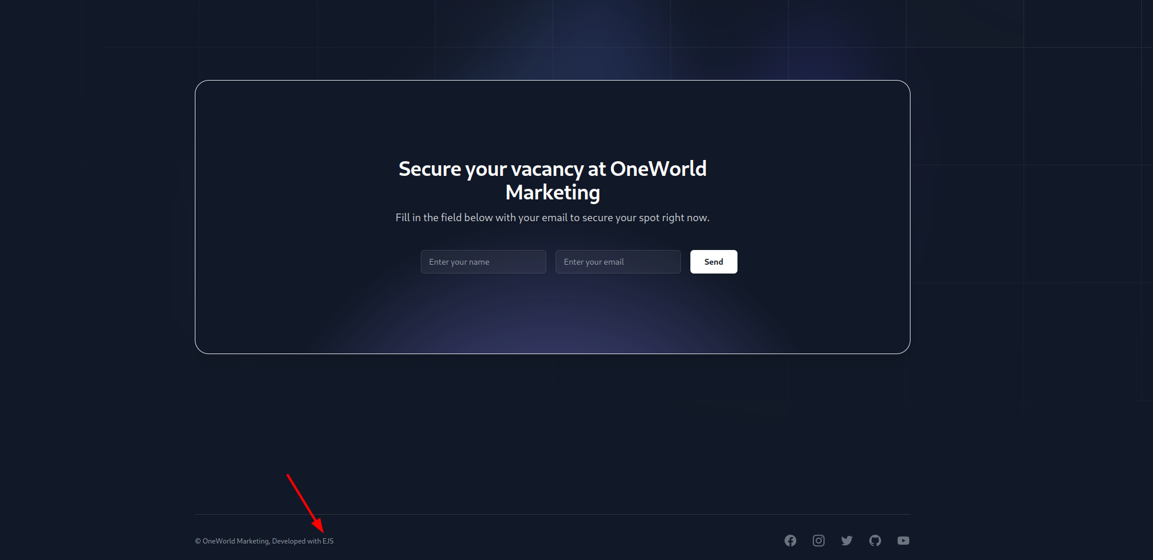
Filling out the form and clicking “send”, we are redirected to another page where our name is reflected.


Researching SSTI in EJS, we find a 2022 CVE that demonstrates a payload to exploit SSTI in this templating system:

EJS, Server side template injection RCE (CVE-2022-29078) - writeup
Note: The objective of this research or any similar research is to improve the Node.js ecosystem security level. Recently, while working on a related project using one of the most popular Node.js templating engines — Embedded JavaScript templates (EJS) — I started analyzing whether the library was vulnerable to server-side template injection. Since the library is open source, we can take a white-box approach and review the source code.
https://eslam.io/posts/ejs-server-side-template-injection-rce/
We see that the PoC instructs us to add the parameter “settings” in the request and send the payload. Submitting the form again and intercepting the request in Burp Suite, we are able to manipulate the request and add the PoC.
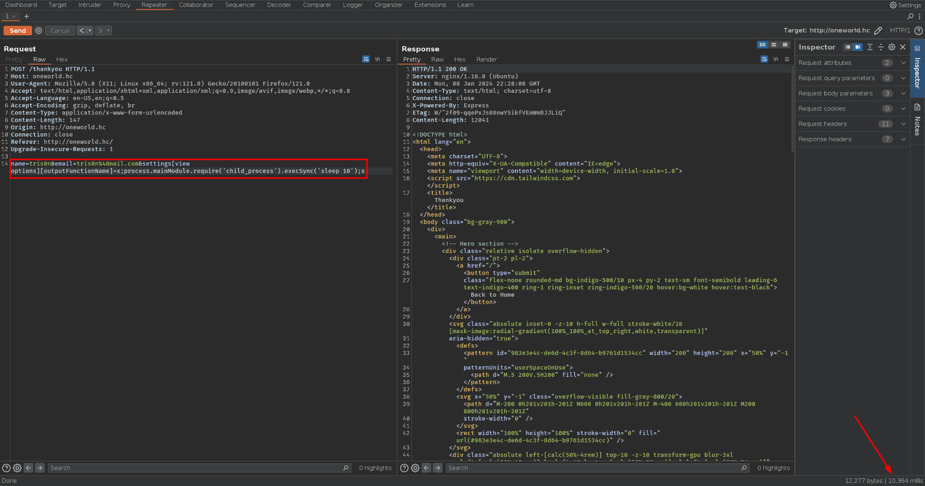
When sending a sleep 10, we observe that the page takes 10 seconds to load — meaning the command was successfully executed. Now, sending a reverse shell payload.
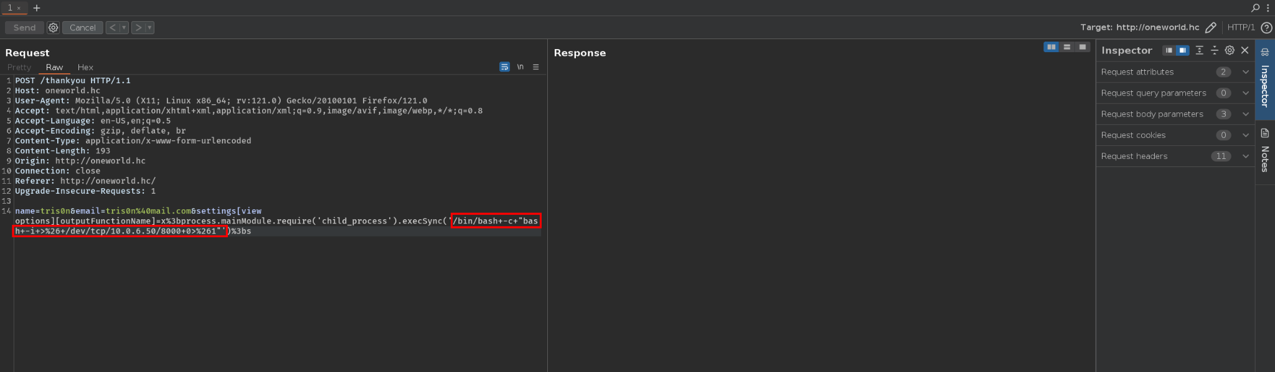
On our netcat listener, we receive the reverse connection:
nc -lvp 8000

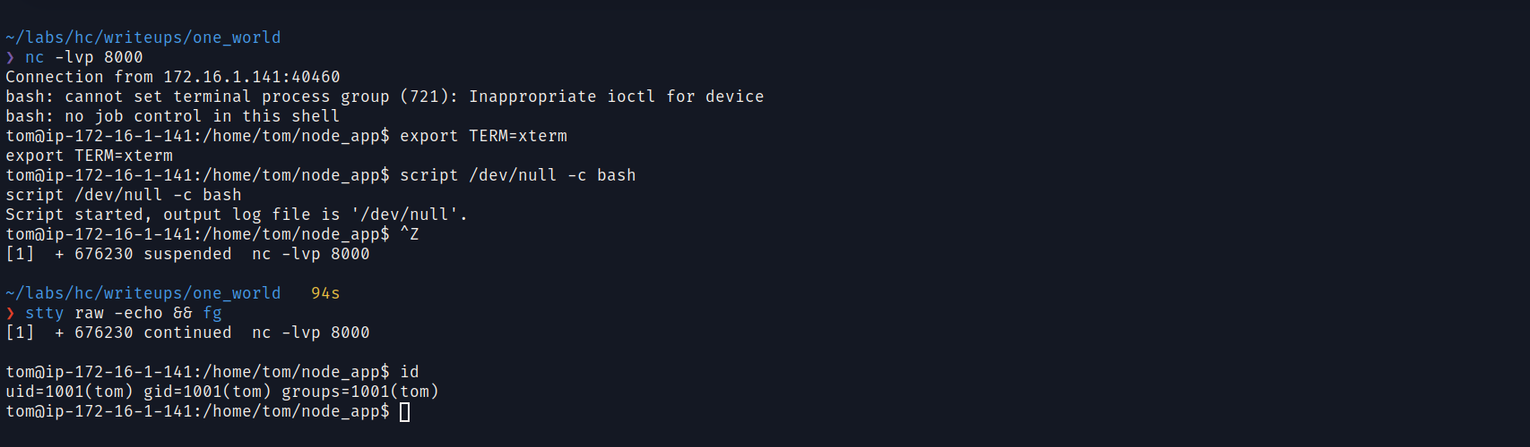
To obtain a fully interactive TTY shell, we execute the following commands:
export TERM=xterm
script /dev/null -c bash
Control + Z (Press)
stty raw -echo && fg
We obtain the user flag at /home/tom/user.txt.
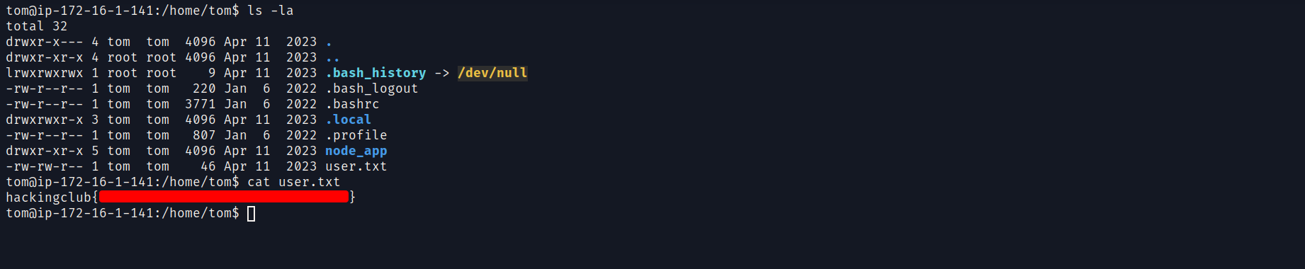

Privilege Escalation
Enumerating sudo permissions, we see that we can execute /opt/backup.sh as root and that we can also set environment variables:
sudo -l
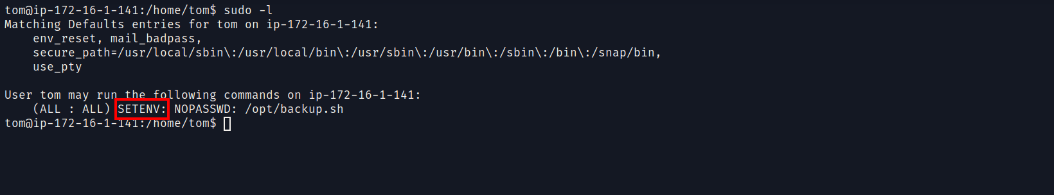
Analyzing the file /opt/backup.sh, we see that it executes the command whoami without specifying the full path. Since we have permission to modify environment variables, we can modify the PATH variable and perform PATH hijacking.
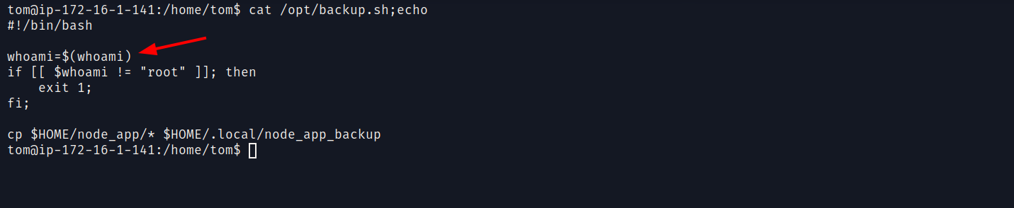
Before performing the path hijacking, we need to create a file called “whoami”, insert our payload into it, and grant it execution permissions:
echo "chmod u+s /bin/bash" > whoami
chmod +x whoami
After creating the file, we can execute /opt/backup.sh while modifying the PATH variable to include /home/tom:
sudo PATH=/home/tom:$PATH /opt/backup.sh
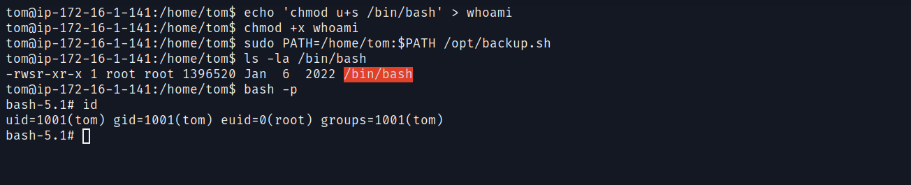
When executed, our payload will run. The payload we placed inside “whoami” grants SUID permissions to /bin/bash.
With SUID permissions set on bash, we simply execute bash -p to obtain a root shell.
We retrieve the root flag at:
cat /root/root.txt

